ACKNOWLEDGMENT

My project was the result of the encouragement of many people who helped in shaping it and provide feedback, direction valuable support. It is with hearty gratitude that I acknowledge their contributions to my project.

I like to thank my internal guides Mrs. Smitha G R and Mr. Nagaraj G Cholli , Assistantt Professor, Department of Information Science & Engineering, RVCE, for the guidance, suggestions in the area of improvement, and implementation of the project.

I am also grateful to the HOD, Dr. Cauvery NK, Department of Information Science & Engineering, RVCE, for permitting me to take up this project and his encouragement. I thank our Principal, Prof. Dr. K N Subramanya, who has always been a great source of inspiration. I thank RSST, for the infrastructure and facilities provided that helped in the completion of the project successfully.

Last, but not the least, I would like to thank my family and friends who provided me with valuable suggestions to improve my project.

Pushpinder Kaur
1RV12IS036

ABSTRACT
In the present system the information of teachers is manually written in logs. This is an extremely time consuming and labor intensive process as there is a need for a person to sit and update the log every time there is an update or change in any teachers records. Also at present, if the head of department wants to view data about a group of teachers or the whole department then there is no method other than to manually go through the logs and find the data.
Faculty Management System automates this system by making the teachers to keep their profiles updated themselves with the help of an online portal. The portal will be designed in an easy to use manner so that the easily register and update their information. The teacher can also update the information regarding him or her using the portal as and when required. The head of departments and the college can also view data about the teachers under them in a consolidated manner and also view just specific fields of all the teachers. Furthermore we will be providing the functionality to generate reports which will be giving pdf files that can be downloaded and viewed.

LIST OF FIGURES
 | Name of Figure | Page No.
Fig 2.1  Fig 3.2  Fig. 3.3  Fig. 3.4.1  Fig. 3.4.2  Fig. 4.1  Fig. 6.1  Fig. 6.2  Fig. 6.3  Fig. 6.4  Fig. 6.5  Fig. 6.6  Fig. 6.7  Fig. 6.8  Fig. 6.9 | Functional Requirement  System Architecture  Entity Relationship Diagram  Dataflow Diagram Level 0  Dataflow Diagram Level 1  Schema Diagram  Snapshot Of Login Page  Snapshot of Registration Page  Snapshot of Overview Page  Snapshot of insert record page  Snapshot of Update Page  Snapshot of Delete Page  Snapshot of Report generation Page  Snapshot of Report generated page  Snapshot of verification email | 6  9  10  11  12  13  21  21  22  22  23  23  24  24  25
LIST OF TABLES
 | Name of Table | Page No.
Table 4.3  Table 6.1 Table 6.2 Table 6.3 | Cardinality Ratios.  Unit test case for FMS  Integration Test case for FMS  System Test case for FMS | 17  22  23  23

TABLE OF CONTENTS
`Sl. No. | Chapter Name | Page No.
1.  2.  3.  4.  5.  6.  7. | Introduction  - Purpose  - Scope  - Motivation  - Literature Survey  Software Requirement Specification  2.1 Overall Description  2.2 Specific Requirements  2.2.1 Functionality  2.2.1.1 Functional Requirement –User  2.3.Non-functional Requirement  Project Design  3.1. Design Considerations  3.1.1 Assumptions and Dependencies  3.1.1.1 Assumptions  3.1.1.2 Functional Dependencies  3.1.2 General Constraints  3.2 System Architecture  3.3 Database Design  3.3.1 Entity Relationship Diagram  3.3.2 Dataflow Diagram  3.3.3 Schema Diagram  3.3.4 Definition of Tables in Database  3.3.5 Definition of Relations and Cardinality Ratio of participating entities  Implementation  4.1 Client – Server specification  4.2 Technologies  Testing  5.1 Unit Testing  5.2 Integration Testing  5.3 System Testing  Results  6.1 Snapshots  6.2 Advantages of the Project  6.3 Limitations of the Project  Conclusion  7.1 Future Enhancement  References  Appendix A List Of Acronyms  Appendix B Coding | 1  1  1  2  3  3  3  4  5  6  6  6  7  8  9  10  12  16  18  19  19  22  23  24  25  29  29  30  31  32  33

Chapter 1

Introduction

1.1 Purpose:
The purpose of developing this site is to make the teachers able to enter their details and manage them as it suits to them. The site aims to provide automated report generation for all sorts of details related to their academic qualification or professional areas such as awards won, books authored, journals published etc.

1.2 Scope:
The project focuses on the staff and students in the campus. This facilitates and eases the amount of paperwork done by the staff as well as the students in the college. The web site will provide all the teachers from Information Science and Engineering Department to enter, update, view or delete their professional and academic details. This is also scaled upto various departments in the college. It can also provide the admin with the facility of generating reports of faculties belonging to different departments and specific department when chosen.

1.3 Motivation:
In the present system the information of teachers is manually written in logs. This is an extremely time consuming and labor intensive process as there is a need for a person to sit and update the log every time there is an update or change in any teachers records. Also at present, if the head of department wants to view data about a group of teachers or the whole department then there is no method other than to manually go through the logs and find the data.
We wish to automate this system by making the teachers to keep their profiles updated themselves with the help of an online portal. The portal will be designed in an easy to use manner so that the easily register and update their information. The teacher can also update the information regarding him/her using the portal as and when required. The head of departments and the college can also view data about the teachers under them in a consolidated manner and also view just specific fields of all the teachers. Furthermore we will be providing the functionality to generate reports which will be giving pdf files that can be downloaded and viewed

1.4 Literature Survey:
From the early 18th century till date, there have been many visionaries, many educationists who all have one goal, the goal to make their education institute big worldwide, so that everyone can take their resources easily. From many years there is been technological advancement in every field, so as in web, we can access the whole world from our desk by just having internet.
So the aim is to provide a portal for faculties to keep the data structured and make life easier for the faculties and the administrative staff. The portal simplifies the operations of inserting, updating and searching of records.
Now the topic of reliability comes into picture, the user should get some satisfaction on which they can rely on; the module is providing ratings which can be used for comparing between different sources.
Regular analysis by the concerned people has given dimensions to the project. The requirements given by the authority has been given the utmost priority and the project fulfills all the requirements. The user interface has been made user friendly and simple for the easy access of the user.

Chapter 2

SOFTWARE REQUIREMENT SPECIFICATIONS

2.1 Overall Description
The proposed system has been designed to help the faculties to store their academic and other information. It also helps the teachers to create and update their details. The data of the faculty is secured at every instance of time. The admin can also manage the accounts of every faculty.

2.2 Specific Requirements
The requirements of the faculty management system are to develop:

RESPONSIBILITIES (INTERNAL REQUIREMENTS)
- Communication Interfaces

Communication between database and front end pages is through PHP, which is auto configured application for virtual server in a computer which is automatically configured. Lampserver is a linux web development environment which allows the user to create web applications with apache2, php and mysql database. Alongside, phpmyadmin also allows managing databases easily. It is connected with front end with a connection string used in HTML pages.

[ Proposed, Medium difficulty ]

Hardware Requirements

- Operating System: Windows XP, Windows Vista, Windows 7, Windows 8
- Processor: Pentium 3.0 or higher
- RAM: 256 Mb or more
- Hard Drive: 300MB or more

[ Proposed, Medium difficulty ]

Software Requirements

- Front End: HTML, CSS, Javascript, AJAX, Jquery, JSON
- Backend: PHP, Mysql
- Browser: Any modern browser that supports AJAX
- OS – Linux or Windows

[ Proposed, Medium difficulty ]

User Interfaces

The database designed should be very easy to use and user friendly
- Admin can see and modify the details of the faculties
- One user can not edit the information of another user
- A user can ret4angalore information of oneself
- Admin can ret4angalore information of all the users.

[ Proposed, Medium difficulty ]

2.2.1 Functionality
The two main user groups and access levels are:
- Student (normal access level)
- Admin (privileged access level)

Therefore, the requirements could be efficiently analyzed depending on the user group and the functionalities they should be allowed to perform.

2.2.1.1 Functional Requirement –User

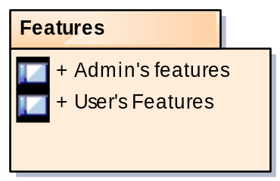

Fig. 2.1 Functional Requirements

Features

Administrator's features

- Admin should be able to generate reports of all faculties
- Admin should be able to generate reports for all faculties in all departments
- Admin should be able to generate department-wise reports
- Admin should be able to change his/her password

User's features

- User should be able to login and register himself/herself to the portal
- User should be able to change password
- User should be able to add documents pertaining to given information
- User should be able to overview the details of each category
- User should be able to update the previous data
- User should be able to filter on the basis of the given fields and then delete the records
- User should also be able to filter the records in order to generate reports in pdfs
- User should be able to generate customized resume, with categories he chooses, between the given dates
- User should be able to upload images of awards won, conference attended and papers or journals published
- User should also be able to upload merit cards for his/her qualification details
.

2.3 Non functional Requirements
2.3.1 Performance Requirement
- The PCs used must be atleast pen5angalomachines so that they can give optimum performance on product.
- In addition to these requirements, the system should also embrace the following requirements
- Reliability - The system should have little or no downtime and be able to handle multiple concurrent users.
- Ease of use - The general and administrative views should be easy to use and intuitive. Online help and documentation should be provided.
- System and browser compatibility testing - The system should be accessible on the following browsers – Microsoft Internet Explorer 7.0+, Netscape Navigator 6.0+ and Mozilla 1.3+, Google Chrome

2.3.2 Security Requirements
It is of utmost importance to ensure that there is a restriction in who can access the database. Users must be provided a unique Registration ID, username and corresponding password to those who can access the system. Similarly, only by having a faculty_id the admin can oversee the various data which has been created by all the faculties. Each client has a password with which he can edit or delete his account. Password recovery is also provided which is sent to the user's ’mail id.

Chapter 3

PROJECT DESIGN

3.1 Design Considerations
3.1.1 Assumptions and Dependencies
3.1.1.1 Assumptions
- It is assumed that faculty’s email id is valid and authentic.
- Every faculty would register into the portal.
- The ids for the documents are generated on the order of insertion.
- The faculties registered are mailed with the activation link.
- The faculties should follow the activation link to activate their account.
- All the forms have a drop down button allowing the user to select only the valid id numbers.
- The data respective to the faculty can be modifies by the faculty. Admin can modify any data.

3.1.2 General Constraints
General Constraints
The design involves the production of technical and visual prototypes. This stage has some non-technical aspects such as gathering of web content; content can be one of the biggest problems in web projects. For the server side programming and other technical aspects of the design emphasis will be laid on such design concepts. The goal is to make the system easier to adapt, enhance, test and use.

Some of the general constraints are:
Clarity of the information
Each information inserted in the project shall be clear, without ambiguity. Each faculty has unique information and faculty_id that should be stored and retrieved as and when required.

Structuring
For guaranteeing reusability of data and its information for different views and layouts the structuring of data and separation of content, layout, and structure should be supported in future.

Verifiability of the information
Each item of information inserted in the project shall be verifiable.
  - System Architecture
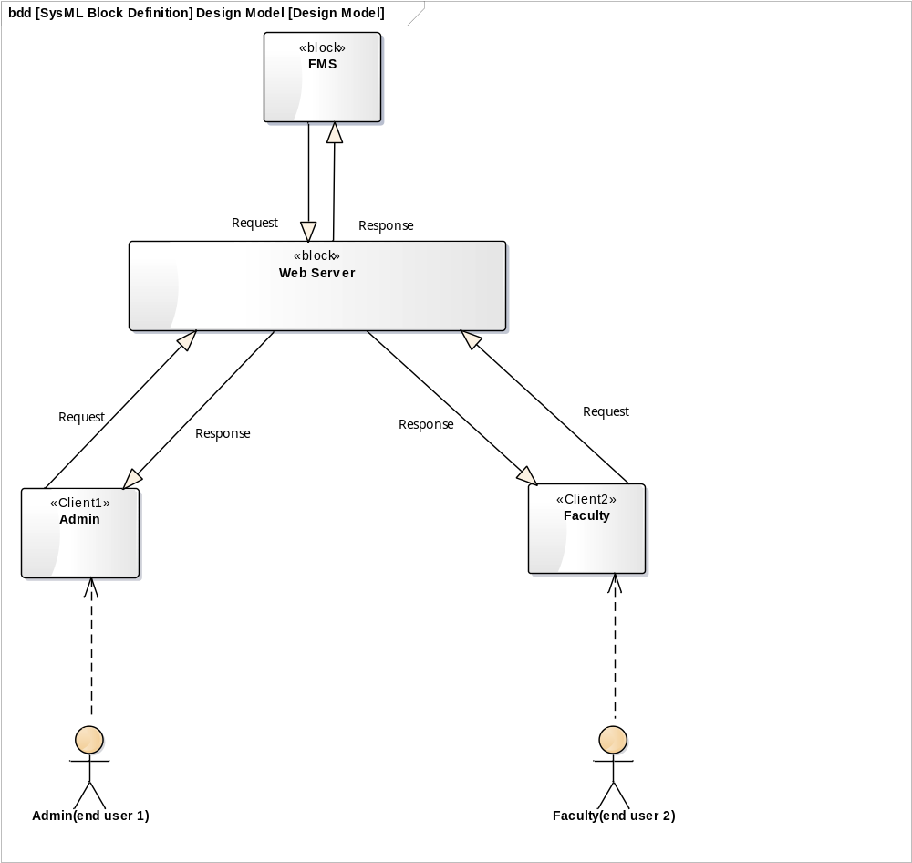
Fig: 3.2 System Architecture

3.4 Database Design
3.4.1 Entity Relationship Diagram

3.4.2 Data Flow Diagram
3.4.2.1 Level 0 Diagram
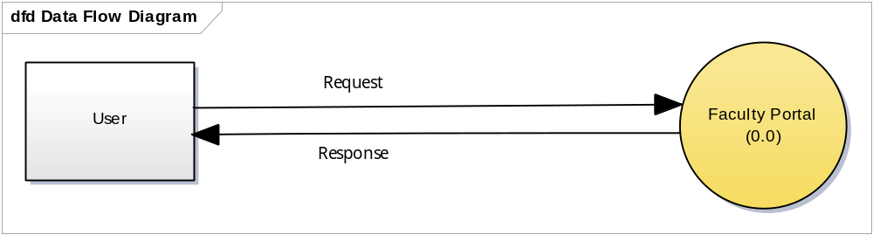
Fig:3.4.1 dataflow diagram level 0

- The User sends a request which is to be authenticated which if allowed for that type of user and if that kind of request exists is allowed and converted into a query.
- If that requests is not authenticated a response to the GUI or user end is generated for eg validations on fields.
- Query hence is executed on the server side and a output is generated and displayed to the user.
3.4.2.2 Level 1 Diagram
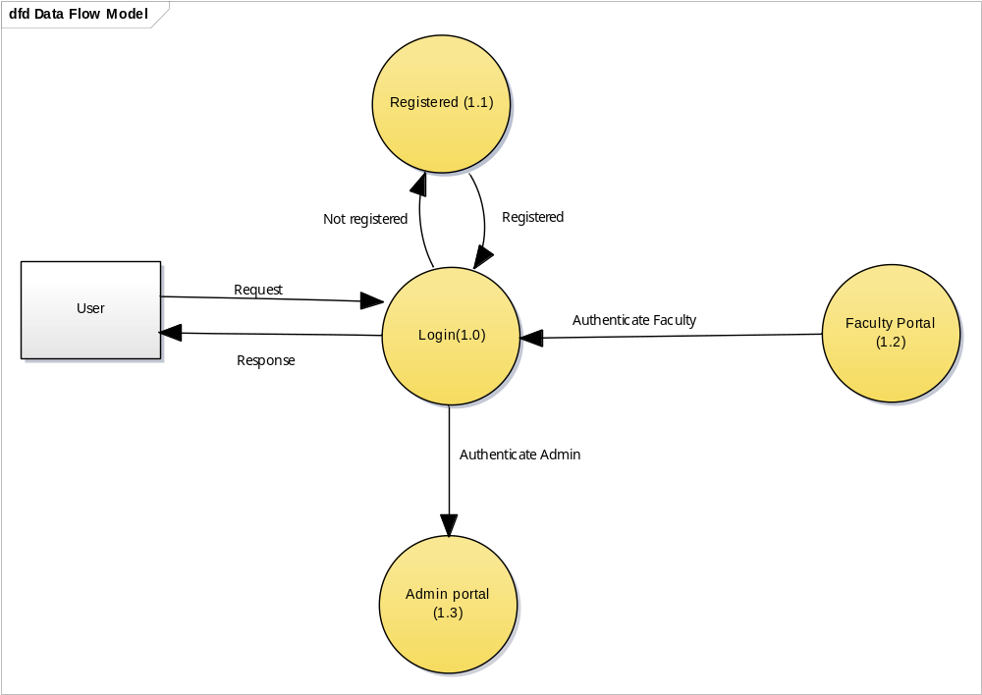
Fig:3.4.2 dataflow diagram level 1

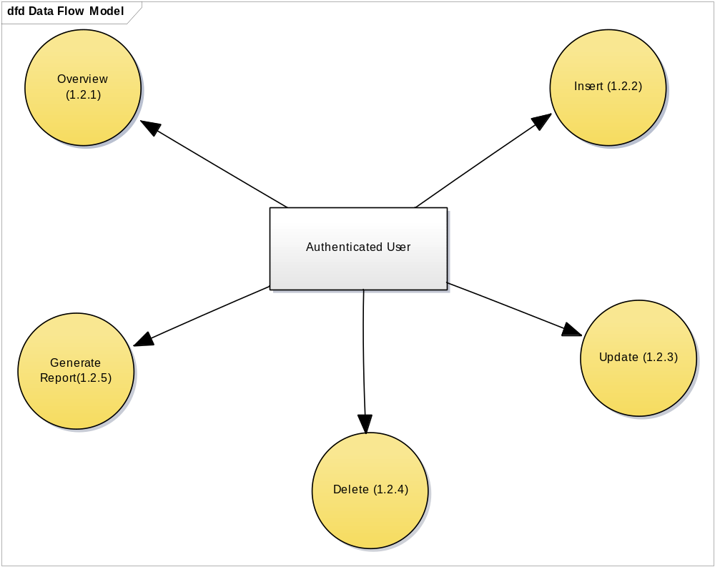
Fig3.4.3: Data flow level 2
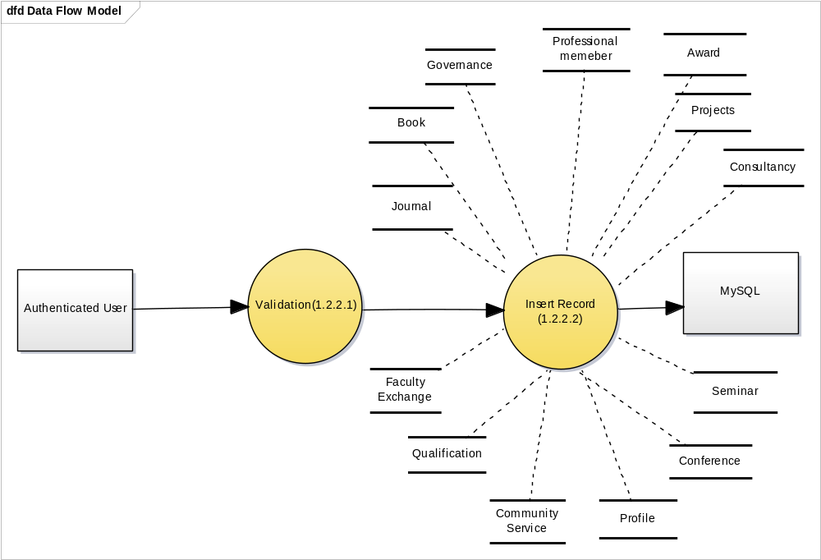
Fig3.4.4: Data flow level:3
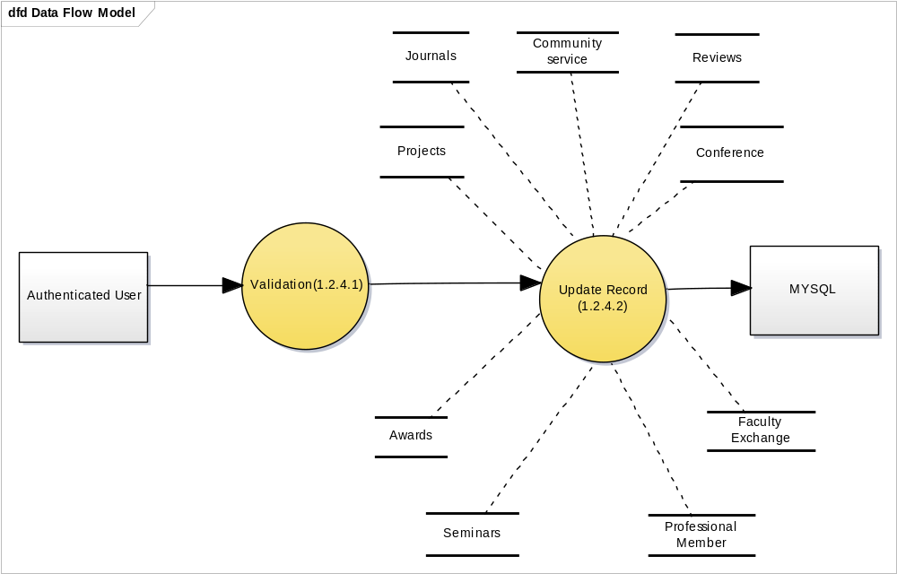
Fig:3.4.5: Data flow level 3
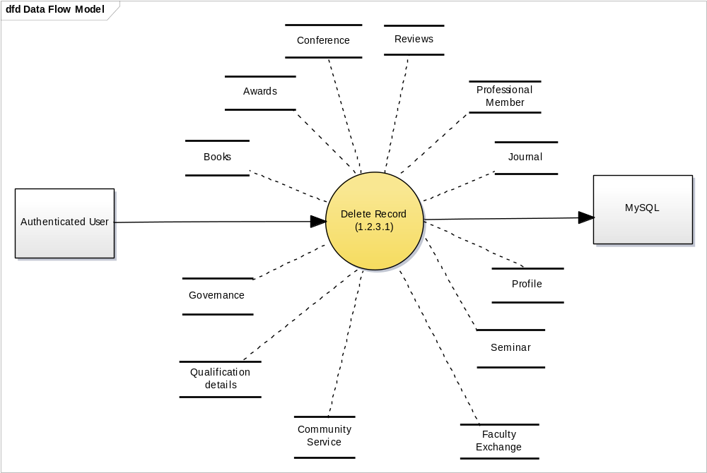 Fig 3.4.6: Data flow level 3
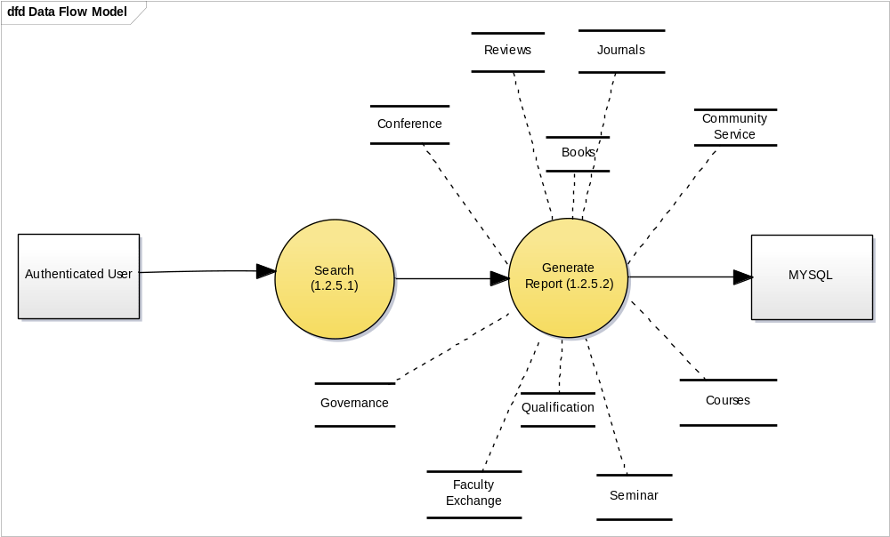
Fig3.4.7: Data flow level 3

3.4.4 Definition of tables in the database

CREATE TABLE IF NOT EXISTS `award` (
`id` varchar(10) NOT NULL,
`award_id` int(11) NOT NULL,
`award_name` varchar(80) NOT NULL,
`award_agency` varchar(80) NOT NULL, `url` varchar(40) DEFAULT NULL,
`remark` varchar(100) DEFAULT NULL,
`file` varchar(250) DEFAULT NULL,
`award_date` date DEFAULT NULL,
PRIMARY KEY (`id`,`award_id`),
KEY `aid` (`award_id`)
) ENGINE=InnoDB DEFAULT CHARSET=latin1;

CREATE TABLE IF NOT EXISTS `book` (
`book_id` int(11) NOT NULL,
`role` varchar(20) NOT NULL,
`book_or_chapter` varchar(20) NOT NULL,
`book_title` varchar(20) NOT NULL,
`book_edition` varchar(20) NOT NULL,
`publisher_name` varchar(20) NOT NULL,
`isbn` varchar(25) NOT NULL,
`id` varchar(10) NOT NULL,
`book_date` date DEFAULT NULL, PRIMARY KEY (`book_id`,`id`),
UNIQUE KEY `isbn` (`isbn`),
KEY `id` (`id`)
) ENGINE=InnoDB DEFAULT CHARSET=latin1;

CREATE TABLE IF NOT EXISTS `book_authors` (
`id` varchar(10) NOT NULL,
`book_id` int(11) NOT NULL,
`author_number` int(11) NOT NULL,
`author_name` varchar(40) NOT NULL,
PRIMARY KEY (`id`,`book_id`,`author_number`),
KEY `book_authors_ibfk_2` (`book_id`)
) ENGINE=InnoDB DEFAULT CHARSET=latin1;

CREATE TABLE IF NOT EXISTS `book_chapters` (
`id` varchar(10) NOT NULL,
`book_id` int(11) NOT NULL,
`chapter_name` varchar(50) NOT NULL,
PRIMARY KEY (`book_id`,`id`,`chapter_name`),
KEY `book_chapters_ibfk_2` (`book_id`),
KEY `id` (`id`)
) ENGINE=InnoDB DEFAULT CHARSET=latin1;

CREATE TABLE IF NOT EXISTS `communityuser` (
`community_user_id` int(11) NOT NULL,
`name_of_event` varchar(40) NOT NULL,
`role` varchar(40) DEFAULT NULL,
`location` varchar(40) DEFAULT NULL,
`date_of_event` date DEFAULT NULL,
`url` varchar(40) DEFAULT NULL,
`additional_information` varchar(40)
DEFAULT NULL,
`id` varchar(10) NOT NULL,
PRIMARY KEY (`community_user_id`,`id`),
KEY `id` (`id`)
) ENGINE=InnoDB DEFAULT CHARSET=latin1;

CREATE TABLE IF NOT EXISTS `conference` (
`id` varchar(10) NOT NULL,
`conference_id` int(11) NOT NULL, `conference_type` varchar(100) NOT NULL,
`research_area` varchar(100) NOT NULL,
`paper_associated_project` varchar(5) NOT NULL,
`project_name` varchar(100) DEFAULT NULL,
`conference_name` varchar(200) NOT NULL,
`organizer` varchar(100) DEFAULT NULL,
`from_date` date NOT NULL,
`to_date` date NOT NULL,
`venue` varchar(100) NOT NULL,
`abstract` varchar(500) NOT NULL,
`keywords` varchar(200) NOT NULL,
`url` varchar(100) DEFAULT NULL,
`file` varchar(500) NOT NULL,
`from_page` int(11) DEFAULT NULL,
`to_page` int(11) DEFAULT NULL,
`paper_title` varchar(100) DEFAULT NULL,
PRIMARY KEY (`id`,`conference_id`),
KEY `ctype` (`conference_type`),
KEY `cid` (`conference_id`)
) ENGINE=InnoDB DEFAULT CHARSET=latin1;

CREATE TABLE IF NOT EXISTS `conference_authors` (
`id` varchar(10) NOT NULL,
`conference_id` int(11) NOT NULL,
`author_name` varchar(40) NOT NULL,
PRIMARY KEY (`id`,`conference_id`,`author_name`),
KEY `con_id` (`conference_id`)
) ENGINE=InnoDB DEFAULT CHARSET=latin1;

CREATE TABLE IF NOT EXISTS `consultancy` (
`consultancy_id` int(11) NOT NULL,
`client` varchar(80) NOT NULL,
`work_title` varchar(80) NOT NULL,
`start_date` date NOT NULL,
`end_date` date NOT NULL,
`revenue_generated` varchar(15) NOT NULL,
`summary` varchar(100) DEFAULT NULL,
`labs_allocated` varchar(100) DEFAULT NULL,
`url` varchar(40) DEFAULT NULL,
`id` varchar(10) NOT NULL DEFAULT '',‘’ PRIMARY KEY (`consultancy_id`,`id`), KEY `id` (`id`)
) ENGINE=InnoDB DEFAULT CHARSET=latin1;

CREATE TABLE IF NOT EXISTS `consultancy_collaboration` (
`id` varchar(10) NOT NULL,
`consultancy_id` int(11) NOT NULL,
`collaborator_name` varchar(40) NOT NULL,
PRIMARY KEY (`id`,`consultancy_id`),
KEY `consultancy_id` (`consultancy_id`)
) ENGINE=InnoDB DEFAULT CHARSET=latin1;

CREATE TABLE IF NOT EXISTS `consultancy_faculty_involved` (
`id` varchar(10) NOT NULL,
`consultancy_id` int(11) NOT NULL,
`fname` varchar(40) NOT NULL,
PRIMARY KEY (`id`,`consultancy_id`,`fname`),
KEY `consultancy_fac_inv_ibfk_3`
(`consultancy_id`)
) ENGINE=InnoDB DEFAULT CHARSET=latin1;

CREATE TABLE IF NOT EXISTS `consultancy_student_involved` (
`id` varchar(10) NOT NULL,
`consultancy_id` int(11) NOT NULL,
`student_usn` varchar(10) NOT NULL,
PRIMARY KEY (`id`,`consultancy_id`,`student_usn`),
KEY `consultancy_id` (`consultancy_id`)
) ENGINE=InnoDB DEFAULT CHARSET=latin1;

CREATE TABLE IF NOT EXISTS `courses_list` (
`course_id` varchar(8) NOT NULL,
`course_name` varchar(40) NOT NULL,
`semester` int(11) NOT NULL,
`ug/pg` varchar(2) NOT NULL,
`syllabus_year` year(4) NOT NULL,
PRIMARY KEY (`course_id`)
) ENGINE=InnoDB DEFAULT CHARSET=latin1;

CREATE TABLE IF NOT EXISTS `courses_taught` (
`course_id` varchar(8) NOT NULL,
`academic_year` year(4) DEFAULT NULL,
`number_of_students` int(4) DEFAULT NULL,
`pass_percent` decimal(5,2) NOT NULL,
`id` varchar(10) NOT NULL DEFAULT '',‘’ PRIMARY KEY (`id`,`course_id`),
KEY `course_id` (`course_id`)
) ENGINE=InnoDB DEFAULT CHARSET=latin1;

CREATE TABLE IF NOT EXISTS `faculty_exchange_program` (
`id` varchar(10) NOT NULL,
`institution` varchar(40) NOT NULL,
`subject` varchar(20) NOT NULL,
`start_date` date NOT NULL,
`end_date` date NOT NULL,
`ug_pg` varchar(20) NOT NULL,
`collaboration_type` varchar(20) NOT NULL,
`details_of_collaboration` varchar(20)
DEFAULT NULL,
`feedback` text NOT NULL,
PRIMARY KEY (`id`) ) ENGINE=InnoDB DEFAULT CHARSET=latin1;

CREATE TABLE IF NOT EXISTS `faculty_member` (
`fid` varchar(10) NOT NULL,
`username` varchar(50) NOT NULL, `password` varchar(60) NOT NULL,
`name` varchar(30) NOT NULL,
`address` varchar(100) NOT NULL,
`phone_number` varchar(30) NOT NULL,
`picture` varchar(100) NOT NULL, `gender` varchar(100) NOT NULL,
`email` varchar(30) NOT NULL,
`date_of_join` date NOT NULL,
`date_of_birth` date DEFAULT NULL,
`department` varchar(3) DEFAULT NULL,
PRIMARY KEY (`fid`,`username`),
KEY `fid` (`fid`)
) ENGINE=InnoDB DEFAULT CHARSET=latin1

;

3.4.5 Definition of relations and the cardinality ratios of the participating entities

Sl. No. | Participating  Entity 1 | Relation | Participating  Entity 2 | Cardinality Ratio
1. | Faculty | Has | Profile | 1:1
2. | Faculty | Has won | Awards | M:N
3. | Faculty | Attended/Conducted | Conference | M:N
4. | Faculty | Part of/Conducted | Projects | M:N
5. | Faculty | Was Part of | Faculty_Exchange | M:N
6. | Faculty | Authored | Book/Journals | M:N
7. | Faculty | Teaches | Courses | M:N
Table 3.4 Cardinality Ratios

Chapter 4
IMPLEMENTATION
4.1 Client-Server Specification

The software runs on Client Server Architecture where the server side consists of php scripts running on the server. The server can be run on windows as well as linux based systems. It works best with Apache server 2.4, php 5.5.9 and Mysql server 5.5.xx installed on the system.
The clients can use any AJAX compatible browser. Further specifications for the browsers are listed below:
Mozilla Firefox – Version 31
Google Chrome – Version 44
Having the above mentioned versions of the browsers at the client side enables the use of AJAX and JQuery which is used for the development of the software.
The software developed has fat server architecture, which implies that the clients only need to have minimal configuration for their systems.

4.2 Technologies

The various technologies used for development purposes are:

4.2.1 HTML5
- HTML5 is a markup language used for structuring and presenting content on the World Wide Web. It was finalized, and published, on 28 October 2014 by the World Wide Web Consortium.
- Its core aims are to improve the language with support for the latest multimedia while keeping it easily readable by humans and consistently understood by computers and devices.
- Various new APIs have been included :- Geolocation, Local Storage, etc.

4.2.2 Javascript
- JavaScript is a lightweight, interpreted programming language. It is designed for creating network-centric applications.
- JavaScript is very easy to implement because it is integrated with HTML. It is open and cross-platform.
- Client-side JavaScript is the most common form of the language. The script should be included in or referenced by an HTML document for the code to be interpreted by the browser.
- JavaScript can be used to trap user-initiated events such as button clicks, link navigation, and other actions that the user initiates explicitly or implicitly.
- We can create interfaces that react when the user hovers over them with a mouse or activates them via the keyboard.

4.2.3 JQuery
- JQuery is a fast and concise JavaScript library created by John Resig in 2006. jQuery simplifies HTML document traversing, event handling, animating, and Ajax interactions for Rapid Web Development.
- The JQuery offers an elegant way to capture a wide variety of events, such as a user clicking on a link, without the need to clutter the HTML code itself with event handlers.
- The JQuery helps you a lot to develop a responsive and feature-rich site using AJAX technology.
- JQuery is very lightweight library - a–out 19KB in size.

4.2.4 AJAX
- Ajax is a set of web development techniques utilizing many web technologies used on the client-side to create asynchronous Web applications.
- With Ajax, web applications can send data to and retrieve from a server asynchronously (in the background) without interfering with the display and behavior of the existing page.
- Ajax is not a technology, but a group of technologies. HTML and CSS can be used in combination to mark up and style information. The DOM is accessed with JavaScript to dynamically display – and allow the user to interact with – the information presented.

4.2.5 XML
- XML stands for EXtensible Markup Language.
- XML is designed to store and transport data.
- XML is designed to be self-descriptive.
- XML is designed to be both human- and machine-readable.
- XML is a W3C Recommendation.

4.2.6 CSS
- Cascading Style Sheets, fondly referred to as CSS, is a simple design language intended to simplify the process of making web pages presentable.
- CSS saves time.
- Pages load faster.
- Easy maintenance - T– make a global change, simply change the style, and all elements in all the web pages will be updated automatically.
- Offline Browsing - C–S can store web applications locally with the help of an offline catche.Using of this, we can view offline websites.The cache also ensures faster loading and better overall performance of the website.
- Platform Independence - T–e Script offer consistent platform independence and can support latest browsers as well.

4.2.7 JSON
- JSON or JavaScript Object Notation is a lightweight text-based open standard designed for human-readable data interchange.
- It is used while writing JavaScript based applications that includes browser extensions and websites.
- It is primarily used to transmit data between a server and web applications.
- Web services and APIs use JSON format to provide public data.
- It can be used with modern programming languages.

4.2.8 PHP
The programming language used for the development work is PHP. The reason for selection of this language includes among many others the following few.
- Open Source, PHP is completely free.
- PHP can be easily embedded directly into HTML.
- Platform independent can run on Windows Linux or Mac servers.
- Run faster on the internet and easily integrate AJAX, Callback etc.
- Interfaces very easily with Apache/MySQL
- Lots of good books and on-line help.
- It's available with documentation in many languages.
- Easy to learn compared to many other scripting languages. It has a syntax that is easy to parse and is actually rather human-friendly.
- Lots of hosting services have it ready to use, no special configuration.Pretty easy to access other web-based tools through PHP i.e. google maps, etc

4.2.9 MySQL
MySQLi is a relational data base management system (RDBMS) that runs as a server providing multi-user access to a number of databases.
- MySQL is an open source tool.
- MySQL is a popular choice of database for use in web applications, and is a central component of the widely-used LAMP web application software stack — LAMP is an acronym for "Linux, Apache, MySQL, PHP.
- MySQL is primarily an RDBMS and therefore ships with no GUI tools to administer MySQL databases or manage data contained within.
- Microsoft SQL server Express Management studio provides an ease in creating tables by a graphical as well as query based interface.

Chapter 5
TESTING
Software Testing is the process used to help identify the correctness, completeness, security and quality of the developed computer software. Testing is the process of technical investigation and includes the process of executing a program or application with the intent of finding errors.
Test Strategies
Test strategy tells the test plan of the project. It also tells how to test and what to test. The testing done in this project are Unit testing and Integration testing.
- Features to be tested: Form navigation and generation of reports.
- Items to be tested: Functioning of forms and buttons.
- Purpose of testing: To check the effective working of FMS.
- Pass / Fail Criteria: Changes made on the back end like recreation of tables should affect the front end as well. If so, the test is successful.
- Assumptions and Constraints: Tables should be created and values have to be entered at the back end before testing and entity integrity and referential integrity constraints should be taken care
5.1 Unit Testing
Unit testing is a software verification and validation method in which a programmer tests if individual units of source code are fit for use. Some of the tests performed in the project are inserting, delete, retrieve and modify.

Table 5.1 Unit test cases
Name | Object | Test Type | Current Status | Description | Input | Acceptance Criteria | Last Run | Result Details
6 | WorkingSet1 | Standard | Fail | Unit case for search operation (heck the search button) | Keyword=USN  Upon mouse click on button. | Displaying all details with USN matching the Keyword. | Invalid DateTime | No record
5 | WorkingSet1 | Standard | Pass | Unit test case for display operation(check the display button) | USN=”1RV11IS100”  . Upon mouse click on button. | Data successfully retrieved from the database and displayed | Invalid DateTime | Data successfully retrieved from the database and displayed
4 | WorkingSet1 | Standard | Pass | Unit test case for delete operation (Check the delete button) | Username=’admin’,Password=’admin’  Upon mouse click on button. | Visibility of done button | Invalid DateTime | Done Button Appears and profile is deleted
3 | WorkingSet1 | Standard | Pass | Unit test case for update operation (testing of save button) | Password=’admin’,FN=’Bhagya’,LN=’Batra’,address=’#503 Rajajinagar ban19angaloremail_id=’bhagya@vsnl.net’  Upon mouse click on button. | Appearance of Next Button | Invalid DateTime | Next Button Appears
2 | WorkingSet1 | Standard | Pass | Unit test case for login information check operation | USERNAME=’admin’,PASSWORD=’isw’  Upon mouse click on button. | Login Button Appears if login information is correct if not “Invalid Username or Password” appears. | Invalid DateTime | Message: Invalid Username or Password
1 | WorkingSet1 | Standard | Pass | This checks if validation happens while logging in and button appears or not | USERNAME=’admin’,PASSWORD=’admin’  Upon mouse click on button. | Login Button Appears if login information is correct if not “Invalid Username or Password” appears. | Invalid DateTime | Login Button appears.

5.2 INTEGRATION TESTS
Name | Object | Test Type | Current Status | Description | Input | Acceptance Criteria | Last Run | Result Details
3 | WorkingSet1 | Standard | Pass | Password recovery operation | Username=’Admin’ answer(code)=’rvce’ | Message: Original Password display | Invalid DateTime | Message: “admin”-actual password
2 | WorkingSet1 | Standard | Pass | Generation of grid view | Click Search button after entering pattern in textbox | Display of grid view with Name,Contact | Invalid DateTime | Display of grid view with Name,Contact
1 | WorkingSet1 | Standard | Pass | Integrated test for login navigation | Click login button on the login page after entering username and password | Move to Profile page. | Invalid DateTime | Move to Profile page.

Table 5.2 Integration test cases
5.3 System Testing

Name | Object | Test Type | Current Status | Description | Input | Acceptance Criteria | Last Run | Result Details
1 | WorkingSet1 | Standard | Pass | Overall system check | Data entered through forms | Updated data displayed in generated reports | Invalid DateTime | Updated data displayed in generated reports

Table 5.3 System test case

Chapter 6
RESULTS
6.1 Snapshots
Figure 6.1 Snapshot of Login page
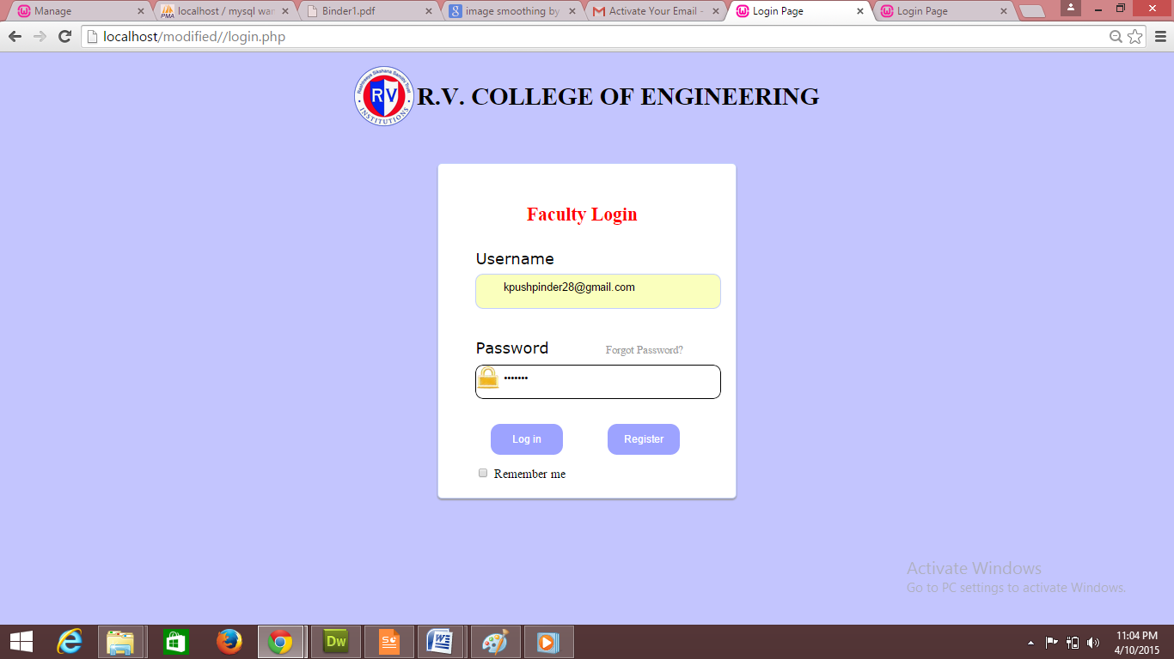

Figure 6.2 Snapshot of Registration page
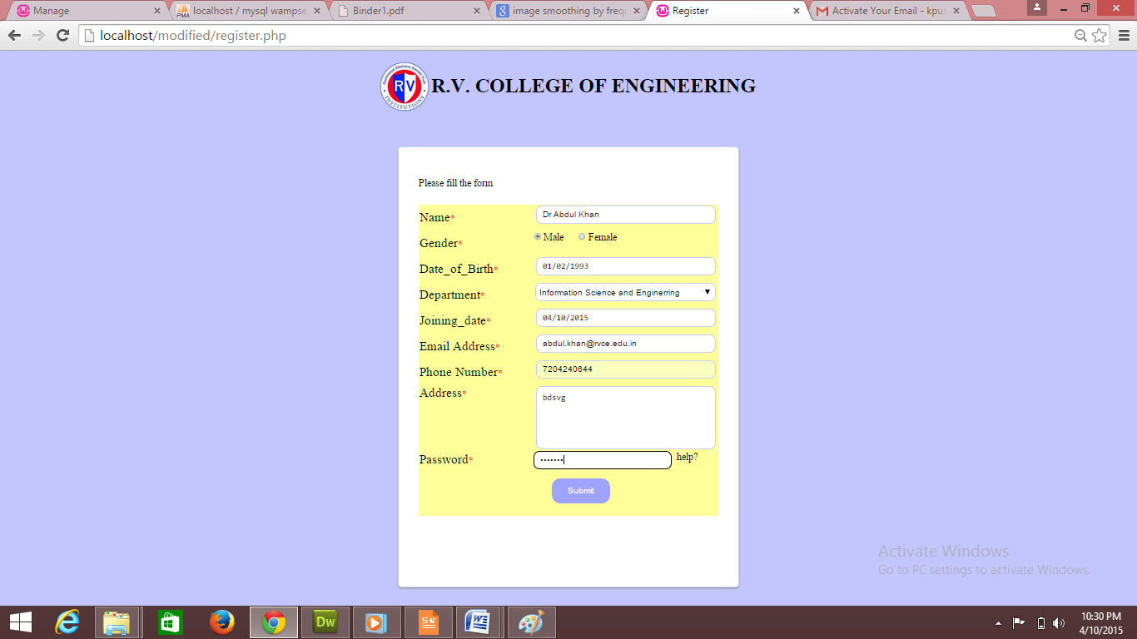

Figure 6.3 Snapshot of overview page
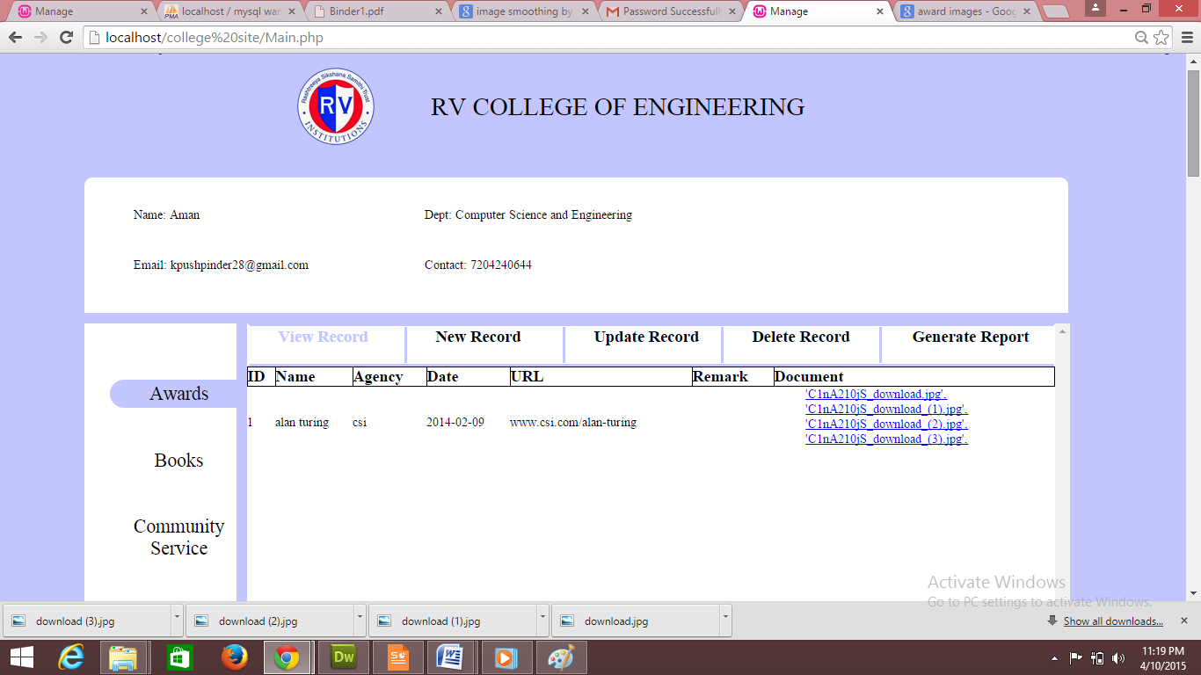

Figure 6.4 Snapshot of insertion page
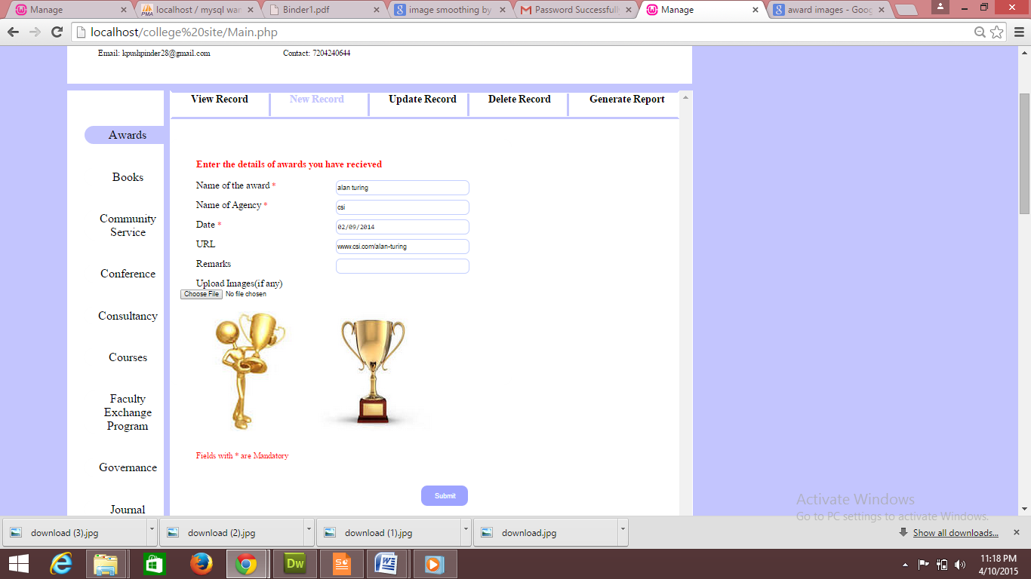

Figure 6.5 Snapshot of update page

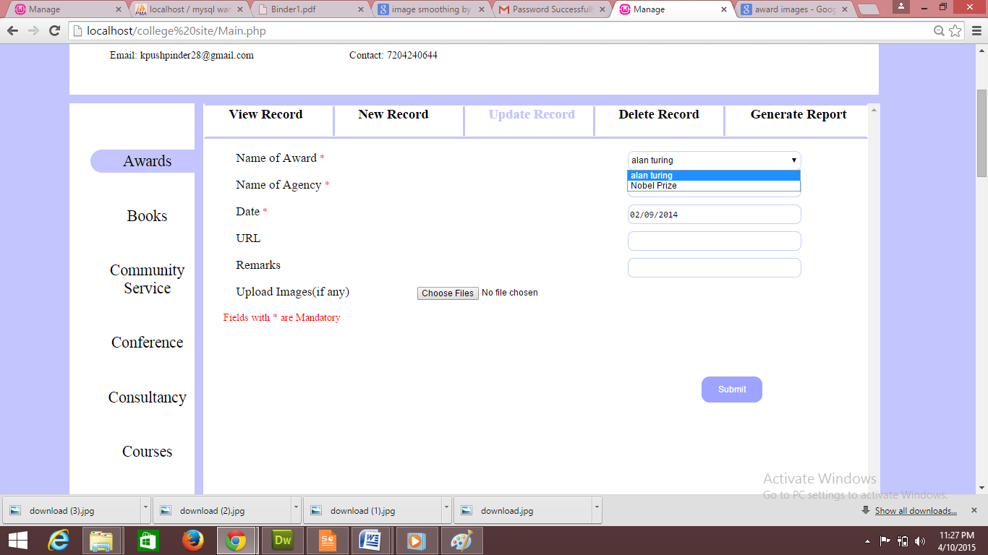

Figure 6.6 Snapshot of deletion page

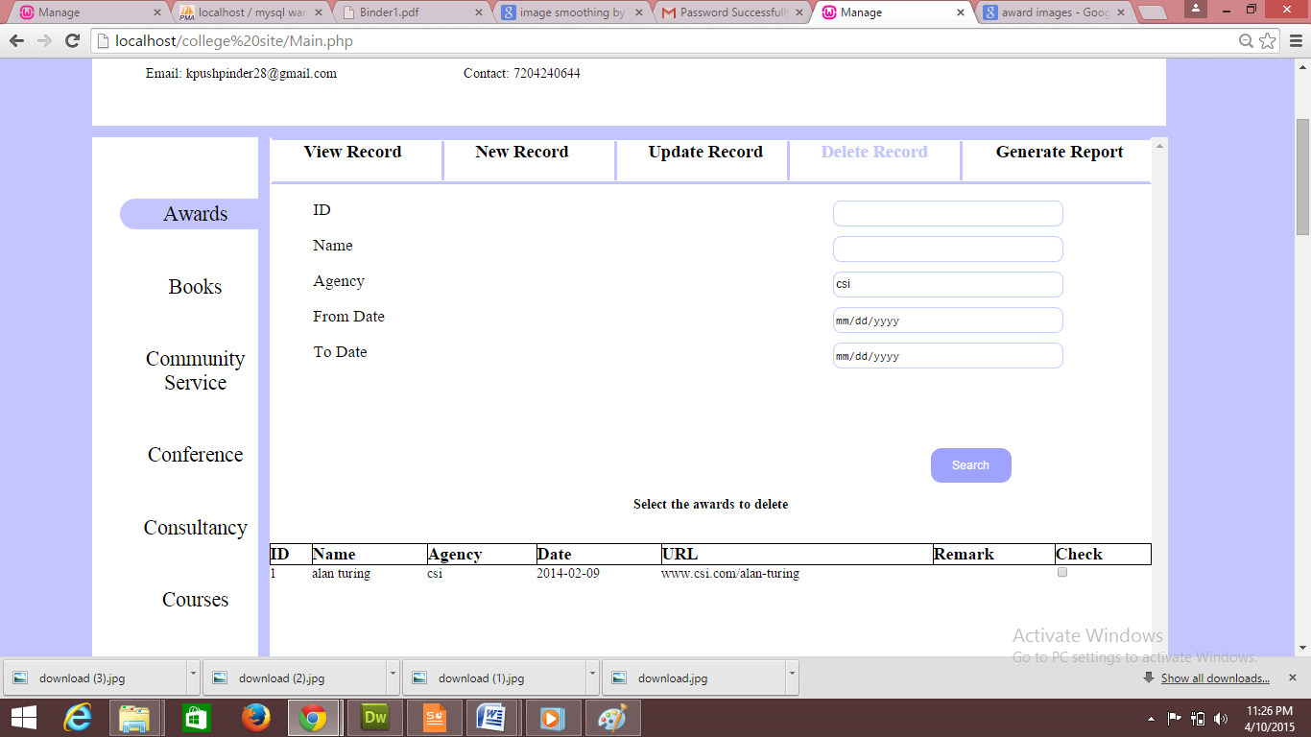

Figure 6.7 Snapshot of report generation page

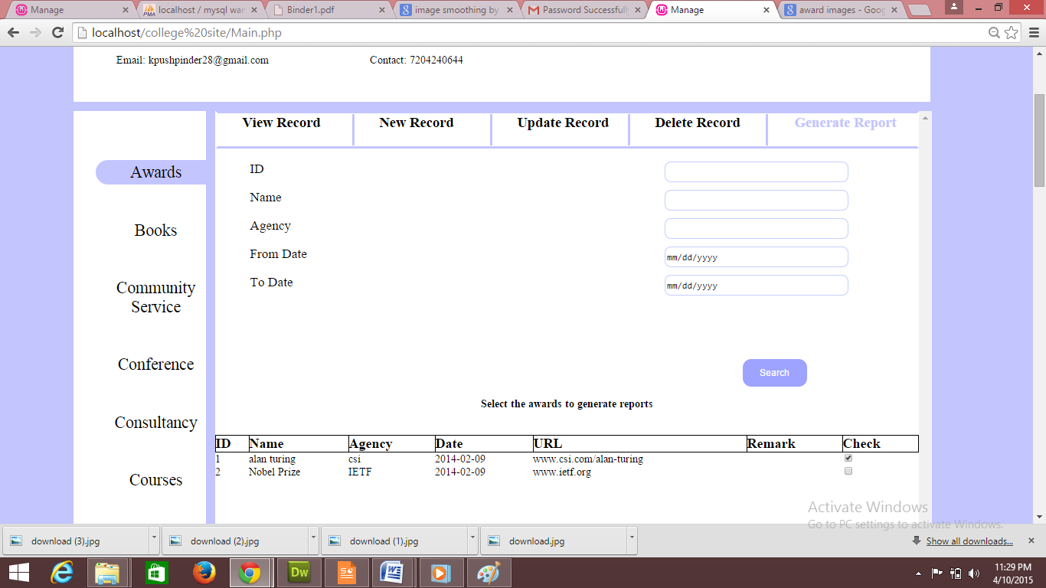

Figure 6.8 Snapshot of report generated

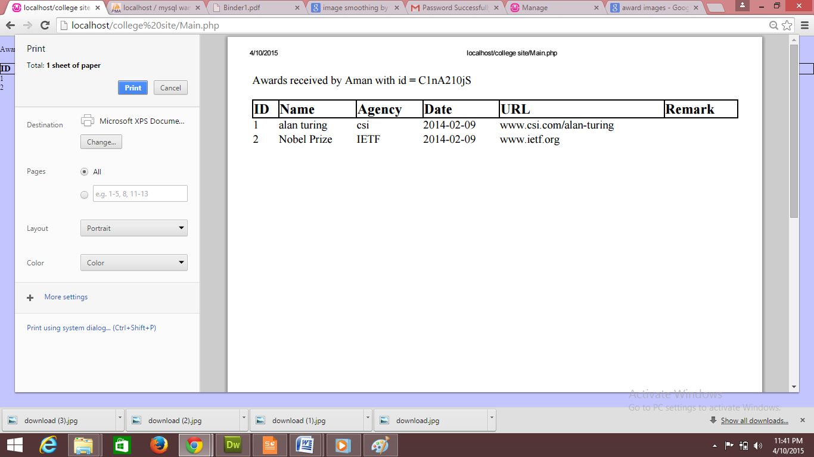

Figure 6.9 Snapshot of verification email

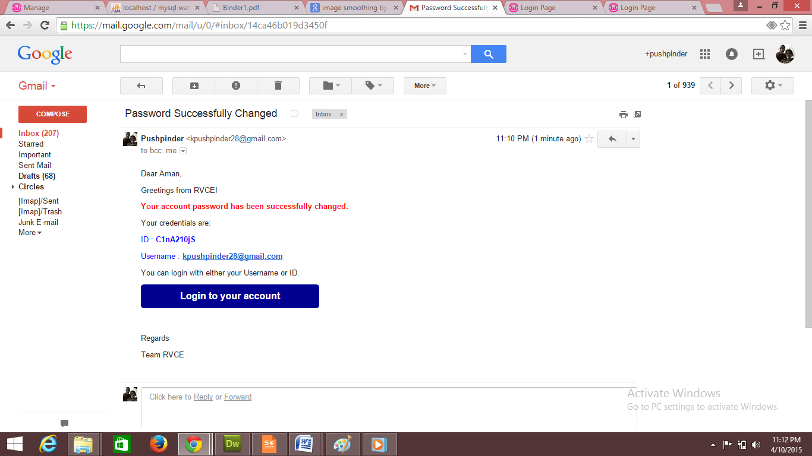

6.2 Advantages of the project
This project is built to provide the following advantages.
- The FMP is created to keep track of all faculty data.
- FMP module provides the facility of username and password for each faculty so that they can easily access or modify their info without taking help of administrator.
- The FMP is one place where the faculty manage all their data
- The FMP module provides the Faculty to view their various acheivments.
- Verification mail is sent to verify the user
- FMP module also provides report generations.
- FMP allows the person to update the data once it is entered

6.3 Limitations of the project
The project has its own limitations
- FMP does not provide the functionality to generate customized reports.
- FMP doesn’t allow the user to manage their college transactions and salary.

Chapter 7
CONCLUSION
The Faculty Management for R V College of Engineering focuses on reducing the human efforts for details of the faculties of the college. Thus FMS module gives customized results all the time, as by giving the pdf of the selected data. The FMS module is tested and re-tested to ensure its effectiveness and provide error free functionality to end user. The AR module hence assures saving of time in finding resources in a appropriate way.

7.1 Future Enhancement
The Faculty Management module can overcome the previously stated limitations by adding few extra features to it such as
- FMS will advance in a spam control for non authorized users.

References
[1] Elmasri and Navathe, Fundamentals of Database Systems, 5th edition, Addison-Wesley, 2007.

[2] Raghu Ramakrishnan and Johannes Gehrke, Database Management Systems, 3rd edition,
McGraw-Hill, 2003.
[3] Silberschatz, Korth and Sudharshan, Database System Concepts, 5th Edition, McGraw-Hill 2006.

[4] Eric T Freeman, Elizabeth Freeman, Elizabeth Robson, Head First HTML with CSS & XHTML, OReilly’
[5] C.J.Date, A.Kannan, S.Swamynatham, A Introduction to Database Systems, 8th edition,
Pearson Education, 2006.
[6] www.w3schools.com for online tutorials on PHP, HTML, CSS, MySQL.

Appendix-A

LIST OF ACRONYMS

- FMS: Faculty Management System
- SRS: Software Requirement Specifications
- ER: Entity Relationship
- OS: Operating System
- RAM: Random Access Memory
- SQL: Structured Query Language
- PHP: Hypertext Preprocessor(Personal Home Page)
- RDBMS: Relational Database management system

Appendix-B
CODING

Coding For Login Page

<!DOCTYPE html>
<html>
<head>
<title>Admin Login</title>
<meta name="viewport" content="width=device-width, initial-scale=1.0">
<meta charset="utf-8">
<link href="event.css" rel="stylesheet" type="text/css">
</head>
<body>
<br >
<div align=center><font color="FF0000">
<?php
session_start();
$host="localhost"; // Host name
$username="root"; // Mysql username
$password=""; // Mysql password
$db_name="studentadmission"; // Database name
$tbl_name="student"; // Table name
$f_email_id="";
$f_mobile_number="";

$con=mysqli_connect("$host", "$username", "$password","$db_name")or die("cannot connect");
if (mysqli_connect_errno())
{
echo "Failed to connect to MySQL: " . mysqli_connect_error();
}

$username=$_POST['admusername'];
$password=$_POST['admpassword'];

if($username=="admin" && $password=="admin") { echo("Login successful <br> Click <a href=\"/AC/student_form.html\">here</a> for the admission forms.<br> Click <a href=\"/AC/student_update.html\">here</a> for the updating forms.<br> ");
}
else {
echo "Username and Password not found! You will be redirected to home";
echo("Click <a href=\"/AC/home1.html\">here</a> to go back.<br>");
}

?>

Here Username and Password are being verified by the query if they are not correct then a label is turned on stating “Invalid username and Password”.
If they are correct a session is generated by passing ID of that user to next profile page.

Coding For Insertion in Registration Page

<!DOCTYPE html>
<html>
<head>
<title>Applicant Registration</title>
<meta name="viewport" content="width=device-width, initial-scale=1.0">
<meta charset="utf-8">
<link href="event.css" rel="stylesheet" type="text/css">
<style>
.error {color: #FF0000;}
</style>
</head>
<body>
<br>
<div align=center><font color="FF0000">
<?php

$host="localhost"; // Host name
$username="root"; // Mysql username
$password="abc"; // Mysql password
$db_name="studentadmission"; // Database name
$tbl_name="student"; // Table name
$f_email_id="";
$f_mobile_number="";
$con=mysqli_connect("$host", "$username", "$password","$db_name")or die("cannot connect");
if (mysqli_connect_errno())
{
echo "Failed to connect to MySQL: " . mysqli_connect_error();
}
$a1e=0;
if ($_SERVER["REQUEST_METHOD"] == "POST")
{

if (empty($_POST["Admission_no"]))
{
echo("Admission number is required.<br>");
$a1e=1;
}
else
{$Admission_no = test_input($_POST["Admission_no"]);}

if (empty($_POST["First_name"]))
{ echo("First name is required.<br>");
$a1e=1;
}
else
{$First_name= test_input($_POST["First_name"]);}
if (!preg_match("/^[a-zA-Z ]*$/",$First_name))
{
echo ("Only letters and white space allowed.<br>");
$a1e=1;
}
$Middle_name= test_input($_POST["Middle_name"]);

if (empty($_POST["Last_name"]))
{echo "Last name is required.<br>"; $a1e=1;
}
else
{$Last_name= test_input($_POST["Last_name"]);}
if (!preg_match("/^[a-zA-Z ]*$/",$Last_name))
{
echo "Only letters and white space allowed.<br>";
$a1e=1;
}

if (empty($_POST["Age"]))
{echo "Age is required.<br>";
$a1e=1;
}
else if (!(is_numeric($_POST["Age"])))
{ echo " Enter a valid age.<br>";
echo $Age;
$a1e=1;}
else
{$Age= test_input($_POST["Age"]);}

if (empty($_POST["DOB"]))
{echo "DOB is required.<br>";
$a1e=1;}
else
{$DOB= test_input($_POST["DOB"]);}

$Mother_tongue=$_POST["Mother_tongue"];
if (empty($_POST["Gender"]))
{echo "Gender is required.<br>";
$a1e=1;}
else
{$Gender = test_input($_POST["Gender"]);}

$Blood_group=$_POST["Blood_group"];
$Religion=$_POST["Religion"];
/* $Nationality=$_POST["Nationality"]; */
$Category=$_POST["Category"];

if (empty($_POST["Caste"]))
{echo "Caste is required<br>";
$a1e=1;}
else
{$Caste= test_input($_POST["Caste"]);}
if (!preg_match("/^[a-zA-Z ]*$/",$Caste))
{
echo "Only letters and white space allowed";
$a1e=1;
}
if (empty($_POST["10_markscard"]))
{echo "10th marks card is required<br>";
$a1e=1;}
else
{$markscard10 = test_input($_POST["10_markscard"]);}

if (empty($_POST["12_markscard"]))
{echo "12th marks card is required<br>";
$a1e=1;
}
else
{$markscard12 = test_input($_POST["12_markscard"]);}

if (empty($_POST["Diploma_markscard"]))
{echo "12th marks card is required<br>";
$a1e=1;
}
else
{$Diploma_markscard = test_input($_POST["Diploma_markscard"]);}

if (empty($_POST["TC"]))
{echo "TC is required<br>";
$a1e=1;
}
else
{$TC = test_input($_POST["TC"]);}

if (empty($_POST["eligibility_VTU"]))
{echo "VTU eligibility is required<br>";
$a1e=1;
}
else
{$eligibility_VTU = test_input($_POST["eligibility_VTU"]);}

if (empty($_POST["caste_certi"]))
{echo "Required field caste certificate<br>";
$a1e=1;}
else
{$caste_certi = test_input($_POST["caste_certi"]);}

if (empty($_POST["income_certi"]))
{echo "Required field income certificate <br>";}
else
{$income_certi = test_input($_POST["income_certi"]);}

if (empty($_POST["photograph"]))
{echo "phtograph is required<br>";
$a1e=1;
}
else
{$photograph = test_input($_POST["photograph"]);}

$extra_cirricular=$_POST["extra_cirricular"];
$family_member=$_POST["family_member"];

$family_member_name=$_POST["family_member_name"];
if (!preg_match("/^[a-zA-Z ]*$/",$family_member_name))
{
echo "Only letters and white space allowed<br>";
$a1e=1;
}
$program=$_POST["program"];
$f_batch=$_POST["f_batch"];

$f_mobile_number=test_input($_POST["f_mobile_number"]);
if( !(($f_mobile_number=="") or !preg_match("/^([1]-)?[0-9]{3}-[0-9]{3}-[0-9]{4}$/i", $f_mobile_number)) )
{
echo "Please enter a valid phone number<br>";
$a1e=1;
}

$f_email_id=$_POST["f_email_id"];
$f_email_id = test_input($_POST["f_email_id"]);
if (!($f_email_id=="" or preg_match("/([\w\-]+\@[\w\-]+\.[\w\-]+)/",$f_email_id)))
{
echo "Invalid email format<br>";
$a1e=1;
}

$f_designation=$_POST["f_designation"];
$f_org=$_POST["f_org"];
$f_add_org=$_POST["f_add_org"];

}
if($a1e==1)
{ echo("Error in registration. Click <a href=\"/phase2/student_form.html\">here</a> to go back.<br>");
die(mysqli_error($con));
}

$sql="INSERT INTO student(Admission_no,First_name,Middle_name,Last_name,Age,DOB,Mother_tongue,Gender,Blood_group,Religion,Nationality,Category,Caste,10_markscard,12_markscard,Diploma_markscard,TC, eligibility_VTU, caste_certi, income_certi, photograph, extra_cirricular, family_member,family_member_name, program, f_batch, f_mobile_number,f_email_id, f_designation, f_org,f_add_org)
VALUES('$Admission_no','$First_name','$Middle_name','$Last_name','$Age','$DOB','$Mother_tongue','$Gender','$Blood_group','$Religion','$_POST[Nationality]','$Category','$Caste','$markscard10','$markscard12','$Diploma_markscard','$TC','$eligibility_VTU','$caste_certi','$income_certi','$photograph','$extra_cirricular','$family_member','$family_member_name','$program','$f_batch','$f_mobile_number','$f_email_id','$f_designation','$f_org','$f_add_org')";
$result=mysqli_query($con,$sql);
if (!($result)) {
echo("Error in registration. Click <a href=\"/AC/student_form.html\">here</a> to go back.<br>");
}
else{
echo("Thank you for registering. Click <a href=\"/AC/contact1_form.php\">here</a> to continue.");
}

function test_input($data)
{
$data = trim($data);
$data = stripslashes($data);
$data = htmlspecialchars($data);
return $data;
}

mysqli_close($con);
?>
</font></div>
</body>
</html>

Code for report generation

<!DOCTYPE html>
<html>
<head>
<title>Applicant Registration</title>
<meta name="viewport" content="width=device-width, initial-scale=1.0">
<meta charset="utf-8">
<link href="event.css" rel="stylesheet" type="text/css">
<style>
.error {color: #FF0000;}
</style>
</head>
<body>
<br><br><br><br><br><br><br><br>
<div align=center><font color="000000">

<?php

$host="localhost"; // Host name
$username="root"; // Mysql username
$password="abc"; // Mysql password
$db_name="studentadmission"; // Database name
$tbl_name="student"; // Table name
$f_email_id="";
$f_mobile_number="";
// Connect to server and select database.
$con=mysqli_connect("$host", "$username", "$password","$db_name")or die("cannot connect");

$x = $_POST['Admission_no'];

if (mysqli_connect_errno())
{
echo "Failed to connect to MySQL: " . mysqli_connect_error();
}

$result = mysqli_query($con,"SELECT Admission_no,First_name,Last_name,Age,DOB,Gender,Nationality,Category,eligibility_VTU FROM student");
echo"<h1>Student details are:</h1>" ;
echo "<table border='1'>
<tr>
<th>Admission_no </th>
<th>Firstname</th>
<th>Lastname</th>
<th> Age</th>
<th>DOB </th>
<th> Gender</th>
<th> Nationality</th>
<th> Category</th>
<th> eligibility_VTU</th>
</tr>";

while($row = mysqli_fetch_array($result))
{
echo "<tr>";
echo "<td>" . $row['Admission_no'] . "</td>";
echo "<td>" . $row['First_name'] . "</td>";
echo "<td>" . $row['Last_name'] . "</td>";
echo "<td>" . $row['Age'] . "</td>";
echo "<td>" . $row['DOB'] . "</td>";
echo "<td>" . $row['Gender'] . "</td>";
echo "<td>" . $row['Nationality'] . "</td>";
echo "<td>" . $row['Category'] . "</td>";
echo "<td>" . $row['eligibility_VTU'] . "</td>";
echo "</tr>";
}
echo "</table>";

mysqli_close($con);
?>

